Electronic supplementary information

N-Aminopyrroledione – Hydrazonoketene – Pyrazolium Oxide – Pyrazolone Rearrangements and Pyrazolone Tautomerism

Sieglinde Ebner,^{a,b} Bianca Wallfisch,^{a,b} John Andraos,ª Ilyas Aitbaev,^{b} Michael Kiselewsky,ª Paul V. Bernhardt,ª Gert Kollenz^{b} and Curt Wentrupª*

ªDepartment of Chemistry, School of Molecular and Microbial Sciences, The University of Queensland, Brisbane, Qld 4072, Australia
^{b}Institut für Chemie, Karl-Franzens-Universität Graz, A-8010 Graz, Austria
E-mail: wentrup@uq.edu.au

Figure S1: Observed and calculated IR spectra of pyrazolium oxide 8a

Figures S2 and S3: ORTEP and crystal packing diagram for compound 14

Tables S1-S3: bond lengths and angles for compund 14

Figure S1. IR spectra of pyrazolium oxide 8a; (top) calculated at the B3LYP/6-31G* level; (middle) calculated at the B3LYP/6-31+G* level; (bottom) experimental, Ar matrix, 10 K (ordinates in arbitrary absorbance units)

Figures S2 and S3. ORTEP and crystal packing diagram for compound 14

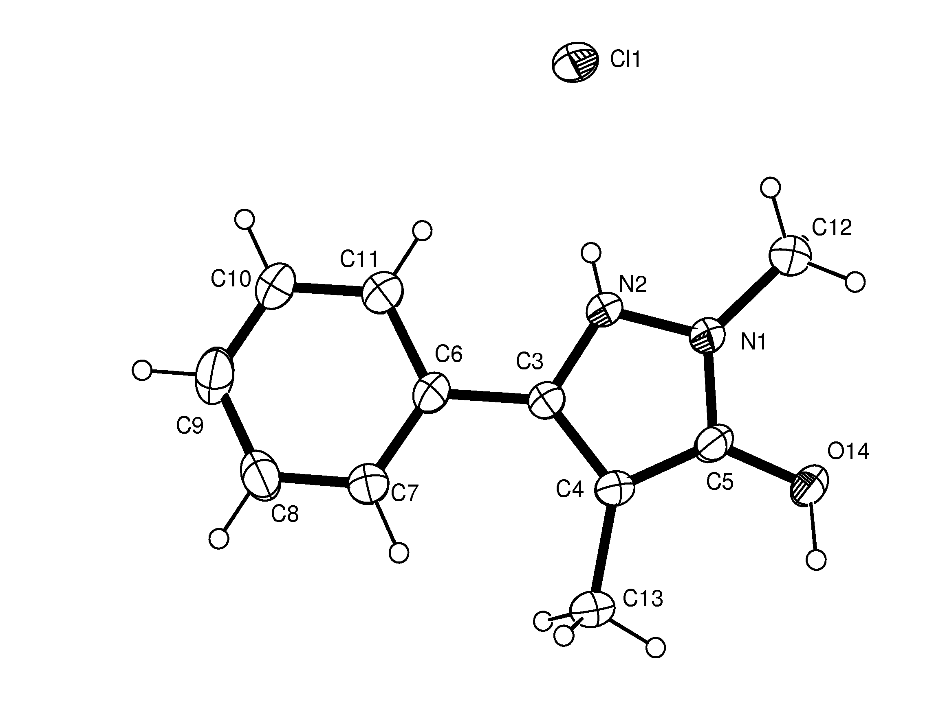
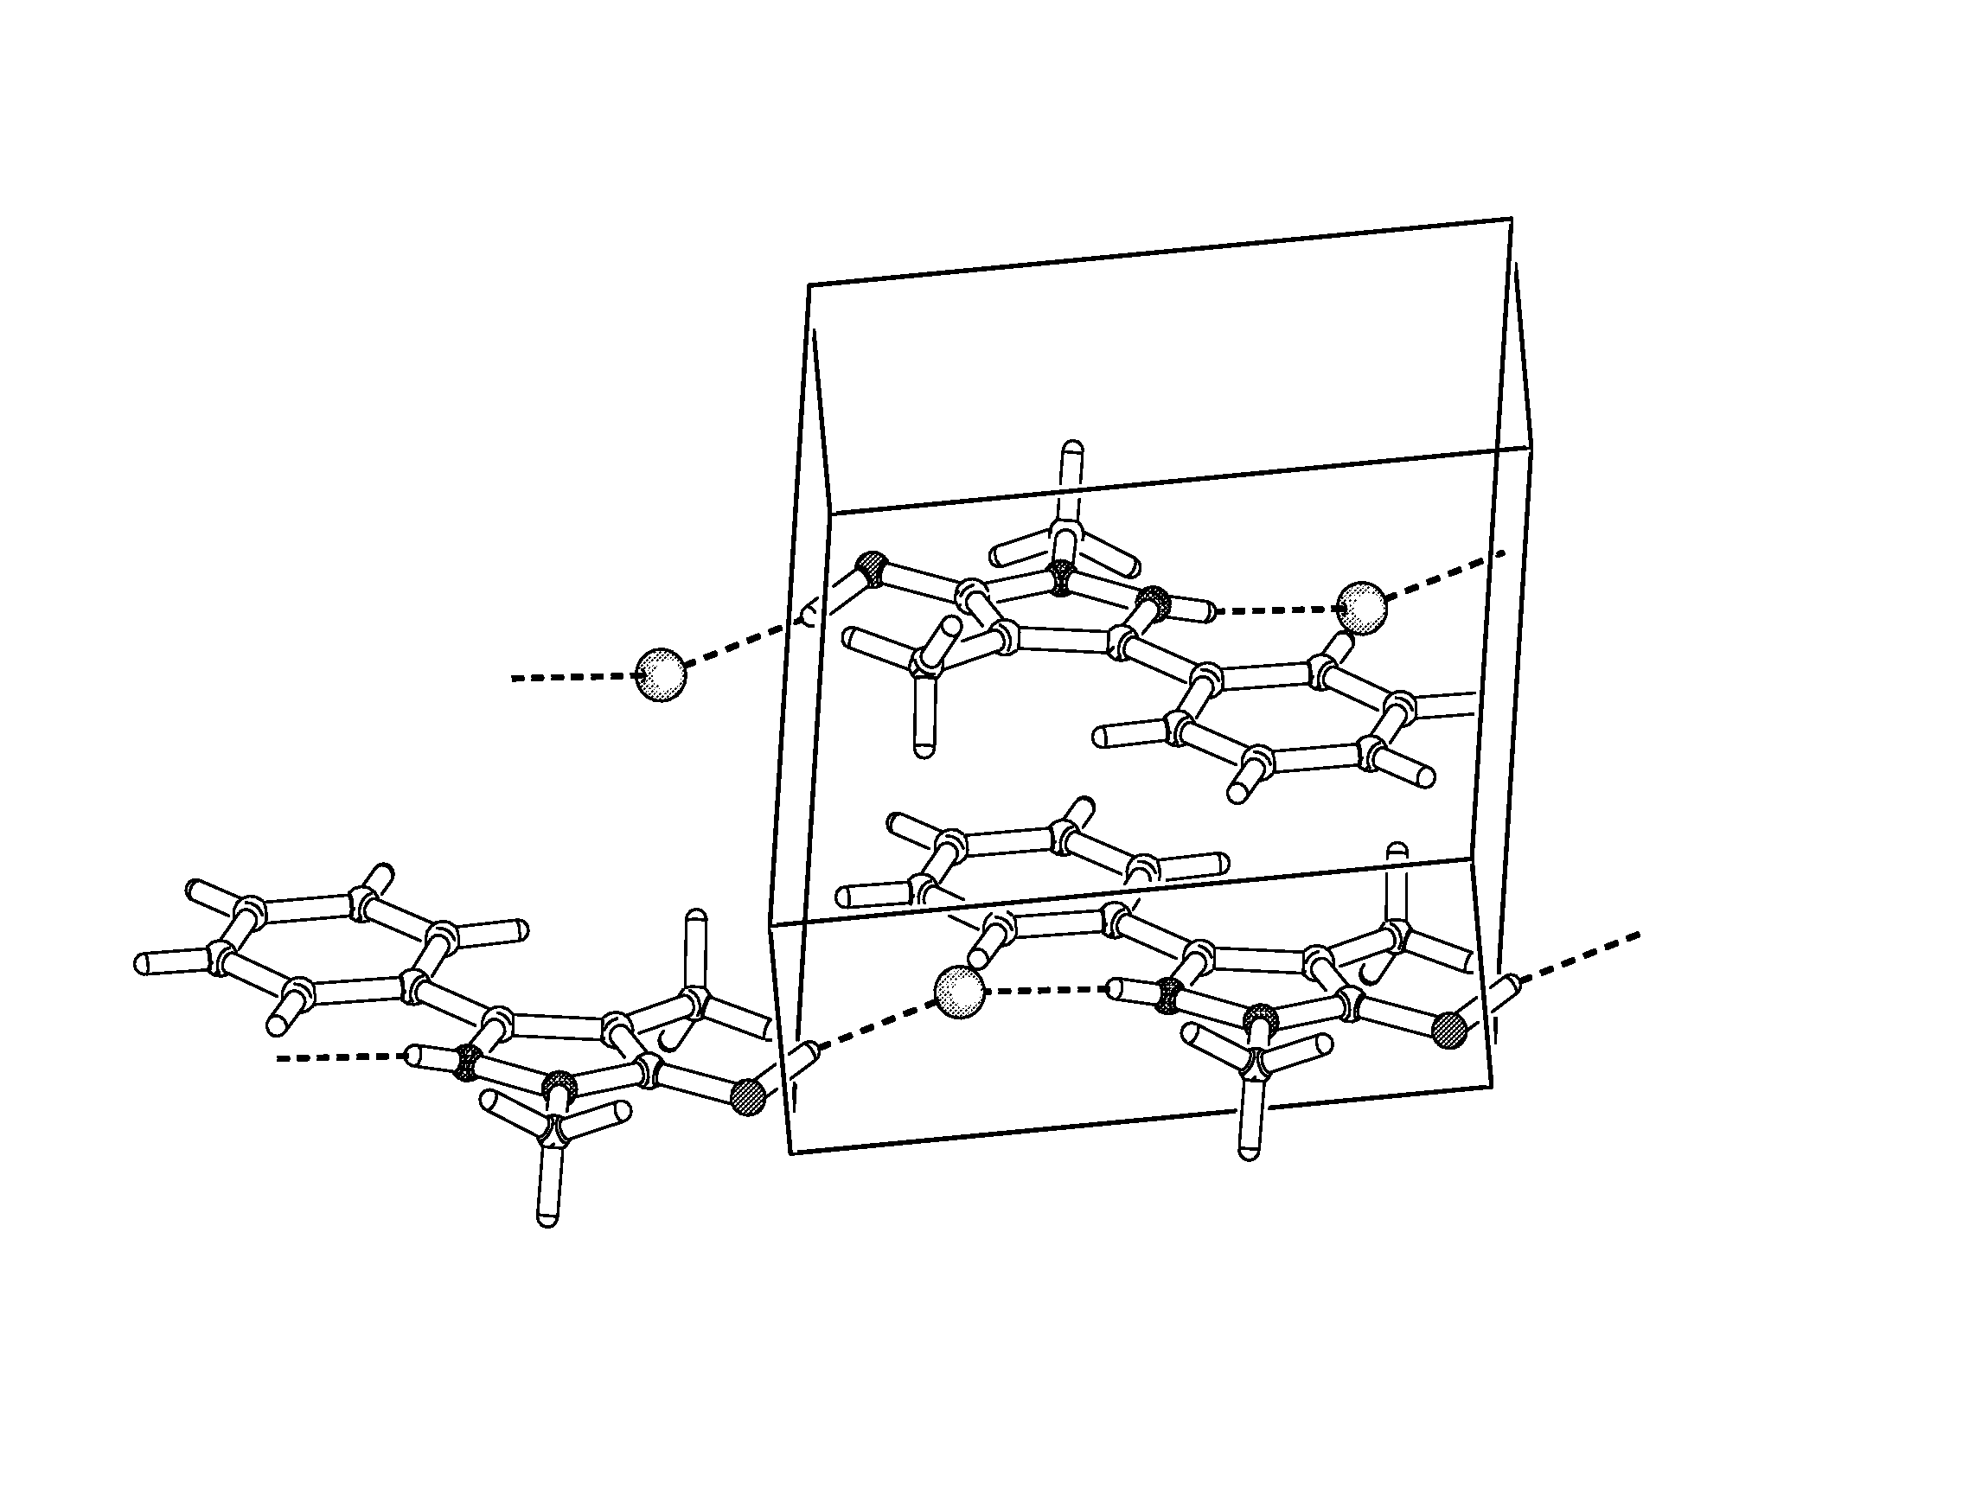
0
c
b
a
O14
Cl1
N2
Table S1. Bond lengths [Å] and angles [°] for 14.
_____________________________________________________
C(3)-N(2) 1.346(6)
C(3)-C(4) 1.391(6)
C(3)-C(6) 1.473(6)
C(4)-C(5) 1.379(6)
C(4)-C(14) 1.507(6)
C(5)-N(1) 1.326(5)
C(5)-O(14) 1.329(5)
C(6)-C(7) 1.382(7)
C(6)-C(11) 1.394(6)
C(7)-C(8) 1.373(7)
C(8)-C(9) 1.370(8)
C(9)-C(10) 1.353(8)
C(10)-C(11) 1.371(7)
C(12)-N(1) 1.454(6)
N(1)-N(2) 1.352(5)

N(2)-C(3)-C(4) 107.6(4)
N(2)-C(3)-C(6) 120.0(4)
C(4)-C(3)-C(6) 132.4(4)
C(5)-C(4)-C(3) 105.1(4)
C(5)-C(4)-C(14) 124.7(4)
C(3)-C(4)-C(14) 130.1(4)
N(1)-C(5)-O(14) 116.5(4)
N(1)-C(5)-C(4) 110.3(4)
O(14)-C(5)-C(4) 133.1(4)
C(7)-C(6)-C(11) 117.6(4)
C(7)-C(6)-C(3) 121.7(4)
C(11)-C(6)-C(3) 120.7(4)
C(8)-C(7)-C(6) 121.0(5)
C(9)-C(8)-C(7) 120.4(5)
C(10)-C(9)-C(8) 119.4(5)
C(9)-C(10)-C(11) 121.3(5)
C(10)-C(11)-C(6) 120.4(5)
C(5)-N(1)-N(2) 107.4(3)
C(5)-N(1)-C(12) 129.4(4)
N(2)-N(1)-C(12) 123.2(4)
C(3)-N(2)-N(1) 109.6(4)
_____________________________________________________________
Symmetry transformations used to generate equivalent atoms:

Table S2. Torsion angles [°] for 14.
________________________________________________________________
N(2)-C(3)-C(4)-C(5) 1.2(6)
C(6)-C(3)-C(4)-C(5) -178.9(5)
N(2)-C(3)-C(4)-C(14) -177.3(6)
C(6)-C(3)-C(4)-C(14) 2.6(9)
C(3)-C(4)-C(5)-N(1) -0.1(6)
C(14)-C(4)-C(5)-N(1) 178.5(5)
C(3)-C(4)-C(5)-O(14) -177.4(6)
C(14)-C(4)-C(5)-O(14) 1.2(10)
N(2)-C(3)-C(6)-C(7) -175.3(5)
C(4)-C(3)-C(6)-C(7) 4.9(9)
N(2)-C(3)-C(6)-C(11) 2.8(7)
C(4)-C(3)-C(6)-C(11) -177.1(5)
C(11)-C(6)-C(7)-C(8) 1.9(9)
C(3)-C(6)-C(7)-C(8) 180.0(5)
C(6)-C(7)-C(8)-C(9) -1.6(10)
C(7)-C(8)-C(9)-C(10) 0.2(10)
C(8)-C(9)-C(10)-C(11) 0.7(10)
C(9)-C(10)-C(11)-C(6) -0.4(10)
C(7)-C(6)-C(11)-C(10) -0.9(9)
C(3)-C(6)-C(11)-C(10) -179.1(5)
O(14)-C(5)-N(1)-N(2) 176.8(5)
C(4)-C(5)-N(1)-N(2) -1.1(6)
O(14)-C(5)-N(1)-C(12) -1.3(8)
C(4)-C(5)-N(1)-C(12) -179.2(5)
C(4)-C(3)-N(2)-N(1) -1.9(5)
C(6)-C(3)-N(2)-N(1) 178.2(4)
C(5)-N(1)-N(2)-C(3) 1.9(5)
C(12)-N(1)-N(2)-C(3) -179.9(5)
________________________________________________________________
Symmetry transformations used to generate equivalent atoms:

Table S3. Hydrogen Bonds for 14.

Distance D..A

3.048(4) N2 … Cl1
2.914(4) O14 … Cl1_$1

Distance H..A

2.33(6) H2…Cl1
1.96(8) H14…Cl1_$1

Angle DH..A

170(6) N2 - H2…Cl1
162(6) O14 - H14…Cl1_$1

Symmetry transformation: $1 x, 1-y, z

